

PHONEBOOK APPLICATION

High Level Design & Low Level Design

**Document Control :**

|  |  |  |  |  |  |  |  |  |
| --- | --- | --- | --- | --- | --- | --- | --- | --- |
| **Phonebook** | | | | | | | | |
| Guided by – SIKANDER |  |  | |  |  |  |  |  |
| **Date** | **Version** | **Author** | **Brief Description of Changes** | | | | **Approver Signature** | |
| 08-11-2022 | 1.0 | Deepthi, Sudheshna, Rasheeda, Vijaya, Varalakshmi. | Modifications like adding, deleting, updating, searching, and displaying the contacts. | | | |  | |
|  |  |  |  | | | |  | |
|  |  |  |  | | | |  | |

**Index**

1. Introduction ------------------------------------------------ 4

1.1 Intended audience ------------------------------------------------ 4

1.2 Project purpose ------------------------------------------------ 4

1.3 Key project objective ------------------------------------------------ 4

1.4 Project scope and limitation ------------------------------------------------ 4

1.5 Functional overview ------------------------------------------------ 4

1.5.1Header files ------------------------------------------------ 4

1.5.2 Functions ------------------------------------------------ 5

2. Design overview ------------------------------------------------ 6

2.1 Design objective ------------------------------------------------ 6

2.2 Design alternative ------------------------------------------------ 6

2.3 User interface paradigms ------------------------------------------------ 7

2.4 Error detection/ Exceptional Handling ------------------------------------------------ 7

2.5 Performance ------------------------------------------------ 7

2.6 Maintenance ------------------------------------------------ 7

3. Diagrams ------------------------------------------------ 8

3.1 Activity Diagram ------------------------------------------------ 8

3.2 Flowchart ------------------------------------------------ 9

4. Environment description ------------------------------------------------10

4.1 Time zone support ------------------------------------------------10

4.2 Language support ------------------------------------------------10

4.3 User desktop requirement ------------------------------------------------10

4.4 Server-side requirement ------------------------------------------------10

4.4.1Deployment consideration ------------------------------------------------10

4.4.2 Application server disk space ------------------------------------------------ 10

4.4.3 Database server disk space ------------------------------------------------10

4.4.4 Integration requirements ----------------------------------------------- 10

4.4.5 Network ------------------------------------------------11

4.5 Configuration ------------------------------------------------11

4.5.1 Operating system ------------------------------------------------11

**1.INTRODUCTION:**

**1.1 Project Purpose: -**

The phonebook is a project that helps us understand the basic concepts of functions, file handling, and data structure. This program will teach us how to add, display, search, update and remove data from/to a file. Adding new records, displaying them, updating, and looking for saved contacts, and removing phonebook records are simple functions that make up the main menu of this Phonebook program.

**1.2 Intended Audience: -**

There are no particular audience set for this project as anyone who uses a phone and wants to add a contact or perform other functionalities with that can use this**.**

**1.3 Key Project Objectives: -**

1. Allow user to enter new record
2. Displays all the entries.
3. Searches from the records.
4. Modification/Updation of records.
5. Deletes record from the file.

**1.4 Project scope and limitation: -**

Instead of writing the contacts in a diary or some other place, we can save all of it at a single place. Also, all sort of Corrections can made in a proper and neat manner.

As far as limitation is concerned, we can’t store any other information apart from name, number, and Email in this project.

**1.5 Functional Overview: -**

**1.5.1** Following header files are included in the program:

1. #include <stdio.h>
2. #include <stdlib.h>
3. #include <stdbool.h >
4. #include <string.h>

**1.5.2** Following functions are included in the program

* Insert (): -
* Insert function takes the input from the user as a contact number and name.
* we check the validity of the number entered with the help of exception handling. If the entered number is less than or greater than 10, a message “Invalid Number” will flash.
* Display (): -
* This function is designed to display all the records of the contact list.
* The name and number of the contact will be displayed.
* Search ():-
* The Search function is used to search a contact in 2 ways. The first one is through search by name.
* This function is used for searching the contact with the help of a name.
* It returns the name and number of the searched contact.
* Search ():-
  + The Search function is used to search a contact in 2 ways. The first one is through search by number.
* This function is used for searching the contact with the help of a number.
* It returns the name and number of the searched contact.
* Modify (): -
  + This function will take name as an input and based on that name; the number will be updated.
* It asks for two options to update. One is to modify name and another one is to modify number.
* Delete (): -
  + This function first searches the contact deletes the contact.
* -2. DESIGN OVERVIEW: -

Phonebook comprises of the following modules:

|  |  |
| --- | --- |
| Name of the Module | Insert Module |
| Handled by | Jangala Vijaya |
| Description | The user adds the record in the file |

|  |  |
| --- | --- |
| Name of the Module | Delete Module |
| Handled by | Shaik Rasheeda Begum |
| Description | The user deletes a record from file |

|  |  |
| --- | --- |
| Name of the Module | Search Module |
| Handled by | Revuri Sai Sudheshna |
| Description | The user searches the record from File |

|  |  |
| --- | --- |
| Name of the Module | Modify Module |
| Handled by | Deepthi J |
| Description | The user updates the record in the File |

|  |  |
| --- | --- |
| Name of the Module | Display Module |
| Handled by | Kosana Varalakshmi |
| Description | It will display the data from file. |

## 

## Design Objectives: -

1. Allow user to enter new record.
2. Displays all the entry.
3. Search from the records
4. Modify/Update the added records.
5. Delete record from file.

**2.2 Design Alternative****: -**

we have used linked list is easier through linked list in C as we must store only data i.e., Mobile no and Name and Email.

### 2.3 User Interface Paradigms: -

* The Phonebook gives a user an option to have its personal contact diary stored on a

system file. A system always works faster than a person can.

* User is given an interface to add a new record in case he wants to add a record, an option to delete a record, search a record with various options, update a record, view the contacts.

### Error Detection / Exceptional Handling: -

* User should first enter the number followed by name else it will display usage error.
* we check the validity of the number entered with the help of exception handling. If the entered number is less than or greater than 10, a message “Invalid Number” will flash.
  1. **Performance: -**

The system will work on the client terminal. The performance depends up on the hardware component of the user’s system.

### Maintenance: -

Very little maintenance should be required for this setup. An initial configuration will be the only system required interaction after system is put together. The only other user maintenance would be any changes to settings after setup, and any specified special cases where user settings or history need to be changed. Physical maintenance on the system’s parts may be required, and would result in temporary loss of data or Internet. Upgrades of hardware and software should have little effect on this project but may result in downtime.

**3.DIAGRAMS:**

**3.1: Activity Diagram:**

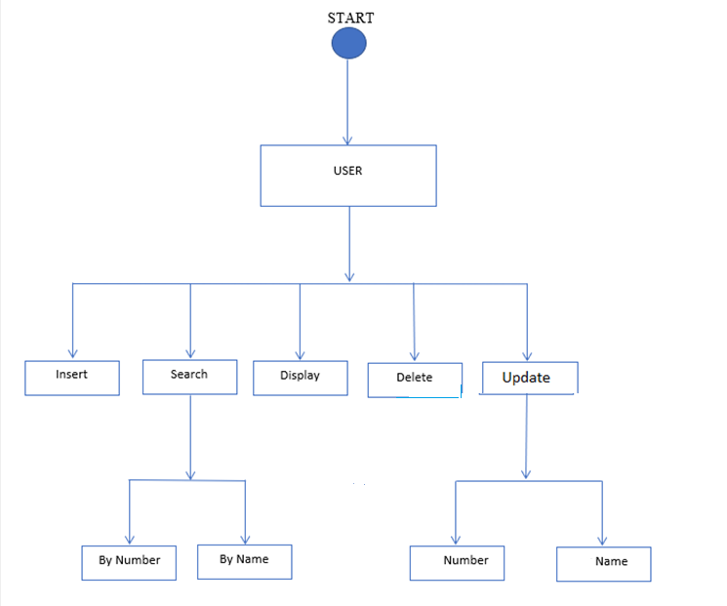

**3.2 Flowchart:**

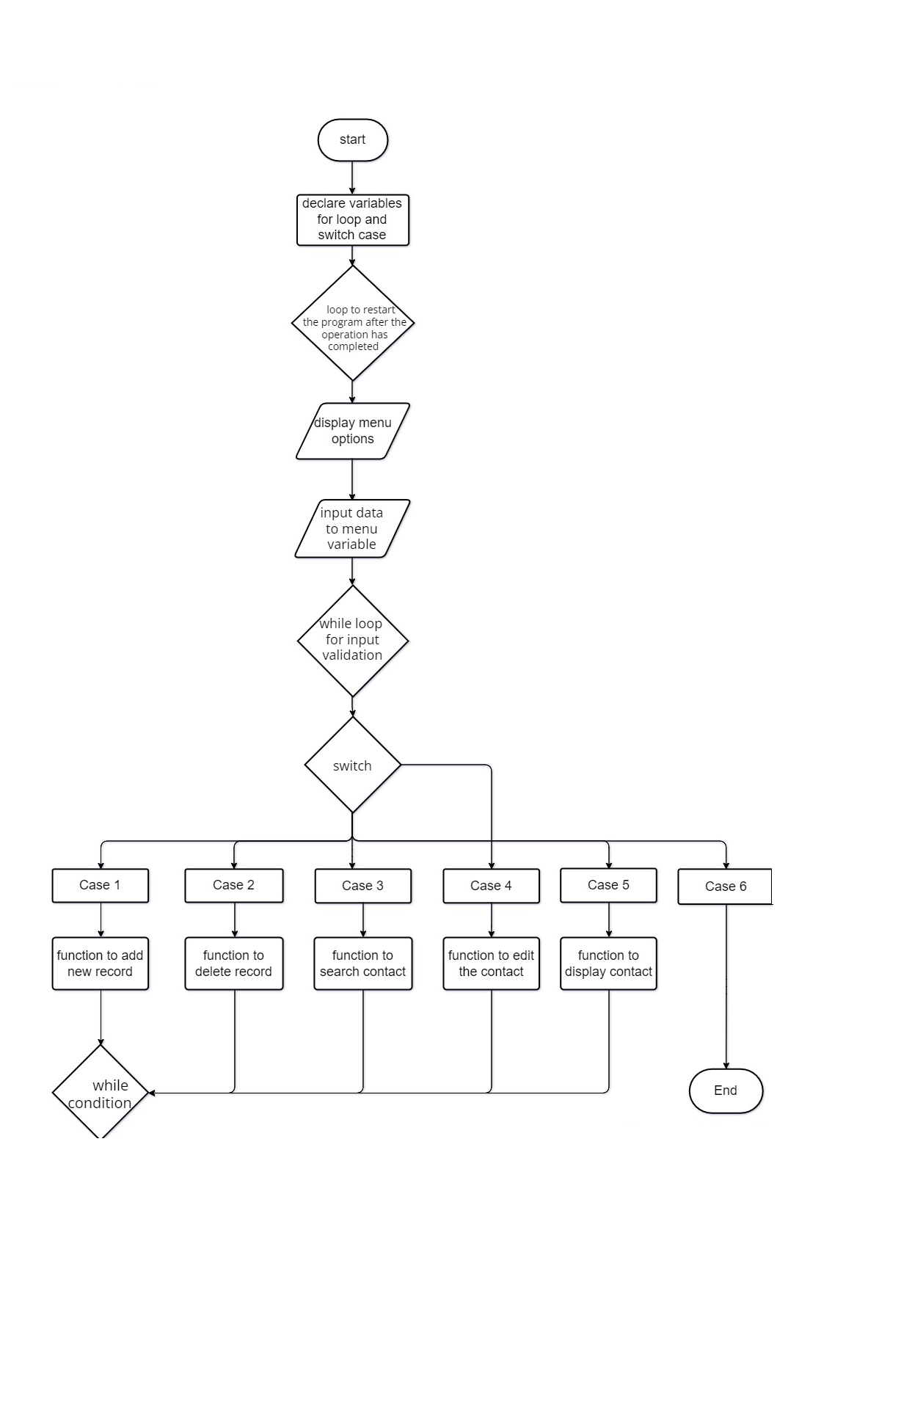

**4. ENVIRONMENT DESCRIPTION:**

**4.1 Time Zone Support: -** IST- Chennai

**4.2 Language Support: -** English

**4.3 User Desktop Requirements: -**

a. 64-bit processor, 1 GHz or faster

b. At least 2 GB free hard drive space

c. At least 1 GB RAM

**4.4 Server-Side Requirements: -**

1. 64-bit processor, 1 GHz or faster
2. At least 1 GB free hard drive space
3. At least 1GB RAM

**4.4.1. Deployment Considerations: -**

* 1. Easy setup: no session storage daemon, use tmpfs and memory caching to enhance performance.
  2. Local storage is used
  3. No network latency to consider
  4. To scale buy a bigger CPU, more memory, larger hard drive, or additional hardware

**4.4.2. Application Server Disk Space: -**

No such disk space is required as the program is fully functional on online

IDE(s) as well. Local Operating System is required and one txt file to store the

records of processes.

**4.4.3. Database Server Disk Space: -**

No such disk space is required as the program is fully functional on online

IDE(s) as well. Local Operating System is required and one txt file to store the

records of processes.

**4.4.4. Integration Requirements: -**

a. Language: - C

b. Tools: -, Valgrind, Make file

c. Complier: - gcc

d. Linux Environment

**4.4.5. Network: -**

a. End to End

**4.5 Configuration: -**

**4.5.1. Operating System:** - Linux environment